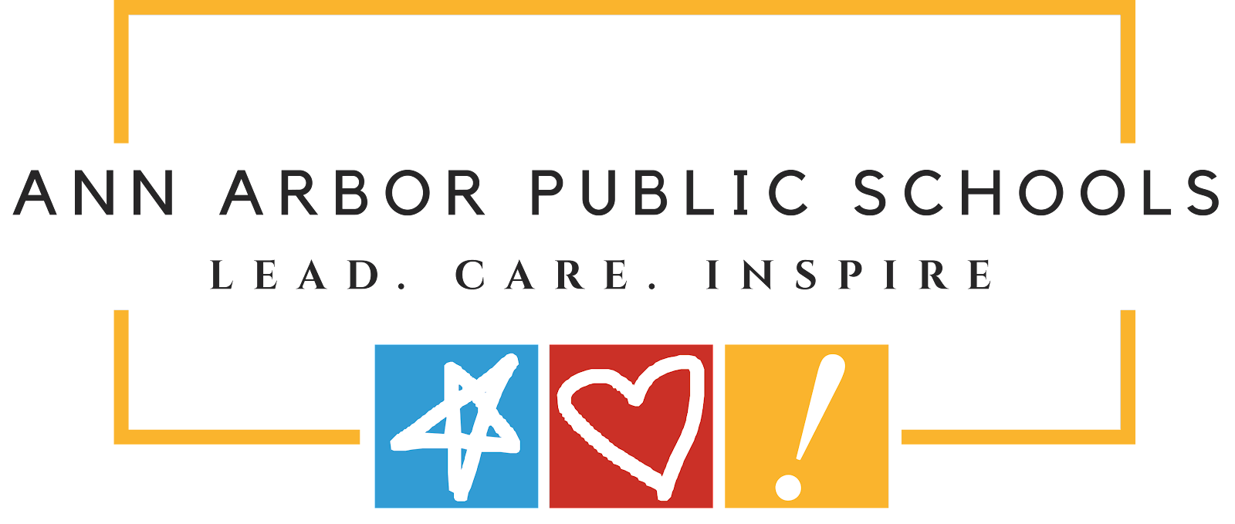

June 3, 2022

Dear Ann Arbor Open Community,

This letter is to inform you that we have been notified of 9 cases of COVID-19 at Open this past week. Positive cases have been asked to isolate according to AAPS protocols. Privacy regulations restrict us from sharing identifying/personal information about the individual(s) who have been diagnosed with COVID-19.

At this time, we are focusing on following up with known positive cases and conducting contact tracing for any higher-risk exposures. If further action is needed, you will be contacted by email or phone.

**As a reminder, we need everyone to do their part to help minimize the spread of COVID-19 in our schools. This includes:**

* Monitoring your child for *any* COVID symptoms using the [Daily Student Pre-Screening for COVID-19 Symptoms](https://docs.google.com/document/d/1fJEQabz4Os1A-oBgqonRjylmhpHfE5svS3brtAa7t5o/edit?usp=sharing),
* **Keep your student home with even mild symptoms**, get tested, and stay home until results come back. [CLICK HERE](https://www.washtenaw.org/3158/Testing) for a list of community testing sites.
* Ensuring your child wears a tight-fitting mask to school
* Getting your student vaccinated and boosted

Please contact your school nurse, Jessica Gagern @ gagernj@aaps.k12.mi.us, with questions.

Sincerely,

Karen Siegel

Principal, Ann Arbor Open