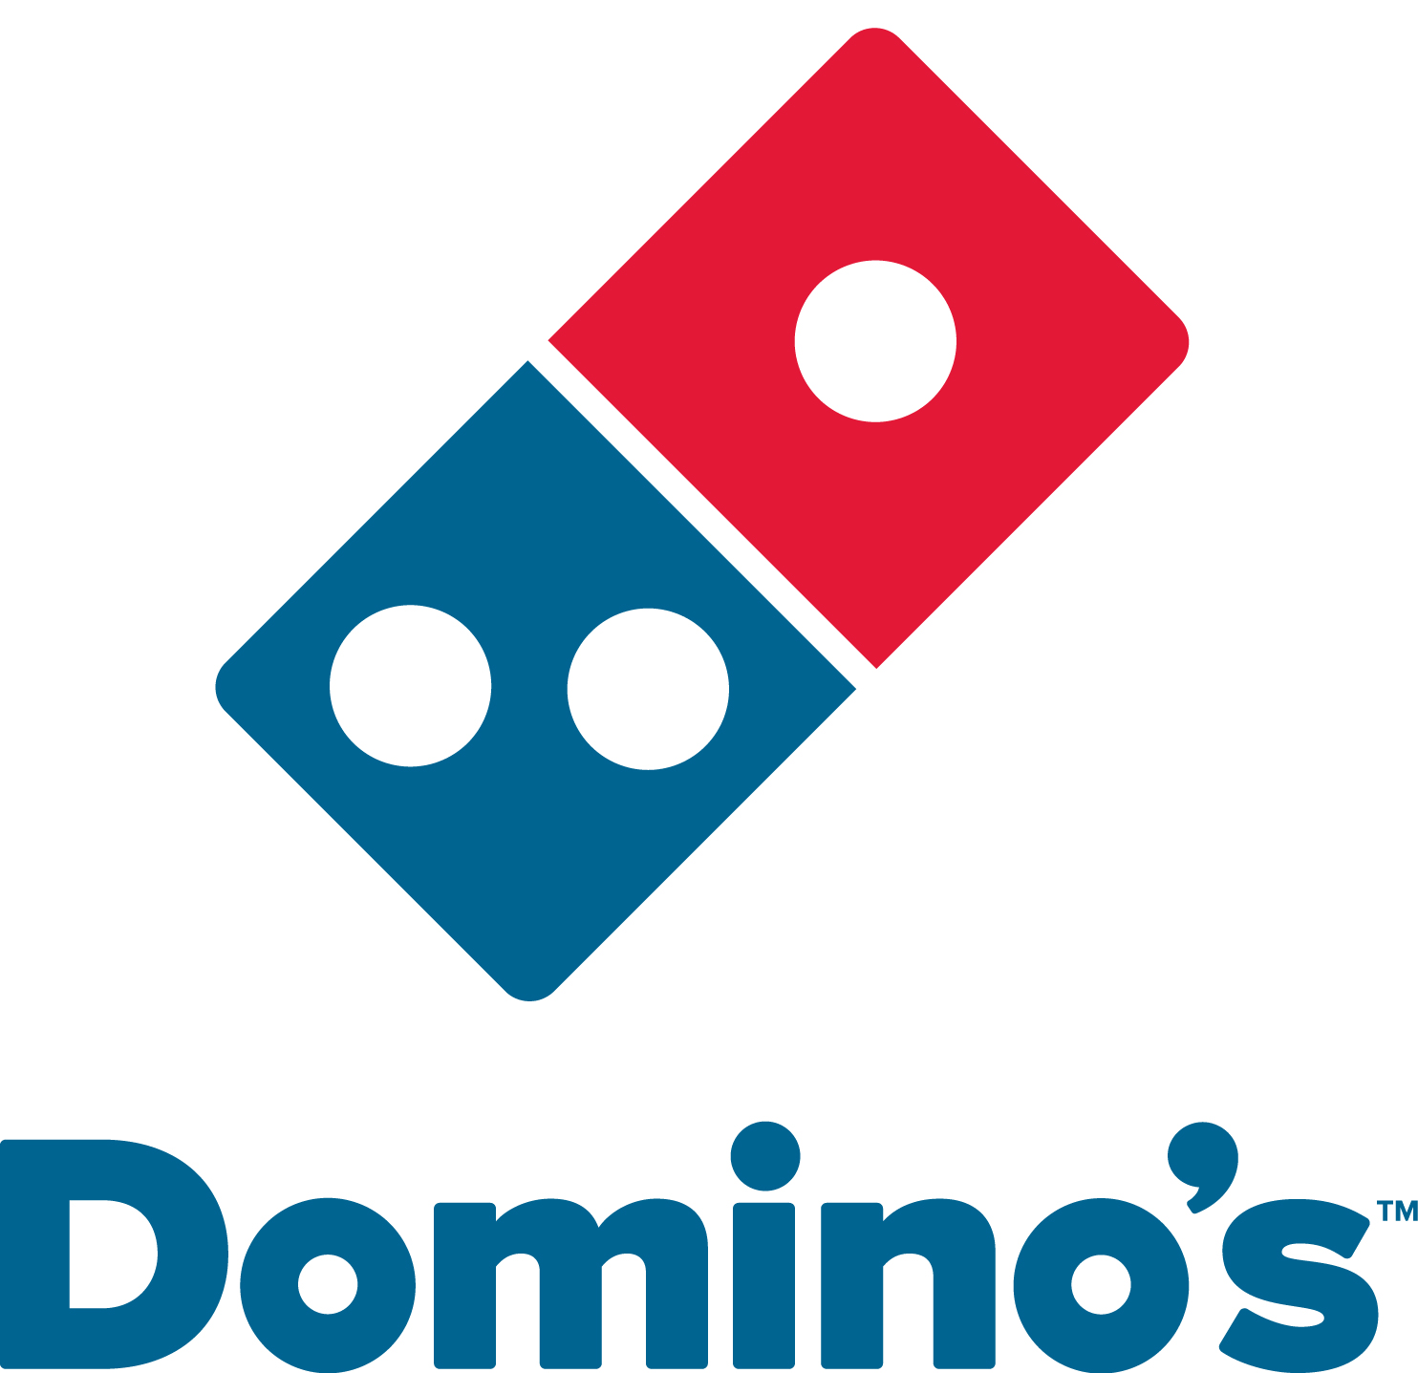

Dear Abbot Parents,

**25% of Net Sales Donated!!**

Your locally owned and operated stores in Ann Arbor are very motivated to support your school by helping raise money for the much needed programs and supplies.

The best part is we developed a fun and easy way for you to participate. All you need to do is eat delicious Domino’s Pizza and **Domino’s will DONATE 25% OF YOUR NET SALE back to your school!** Your local Domino’s is donating all of the profits from your order and matching it!

Once a month (an email will be sent to you and your child will have a sticker attached to their shirt announcing Domino’s pizza days), call the closest store, or order on-line at Dominos.com, and **be sure to mention the coupon code: “A”; your order will be tracked and we will donate 25% cash back.** Don’t forget to hand in the below slip with your information and the class with the greatest participation will receive a FREE PIZZA PARTY!

When ordering on-line: The coupon code will bring up a PARMESAN PACKET. You can select the Parmesan packet- this is our work-around to help flag the school order on-line. You are not charged for it.

**DONATION FORM- PLEASE GIVE TO DOMINO’S**

STUDENT’S NAME:____________________________________________

GRADE__________ TEACHER:________________________________

**Order on-line: DOMINOS.COM or CALL:**

**(734)913-8888 (734)663-3333 734)332-1111**

25 Jackson Ind.Dr 2715 Plymouth Rd 2282 S. Main St

W.Ann Arbor/Scio North Ann Arbor Central/S.Ann Arbor

**25% of the net sale** of your order will be donated to your school!

**MENTION/USE COUPON CODE:**

“A”

DOUGH

RAISER!

